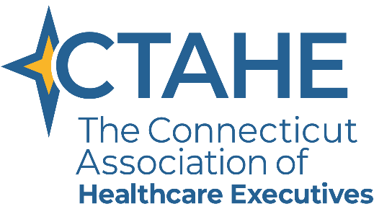
2021 - 2022 CTAHE STUDENT BOARD MEMBER LIAISON APPLICATION

To be eligible to be appointed to the CTAHE Board of Directors as a student liaison, please complete this application and email it along with your resume to Annamarie Grise, CMP, HMCC, Association Executive at administrator@ctahe.org by Friday, April 30th, 2021.

SCHOOL INFORMATION
School Name:
School Address:
E-mail:
Major/Program: | Graduation Date:

The officers, directors, committee chairs, and student board members of CTAHE represent the voice of the chapter’s membership. To ensure that the Board has the vision and the ability to provide the membership with a variety of benefits including opportunities for learning, building relationships, and growing their businesses, it is required that the board collectively possess the following traits:

~ Diversity ~ Commitment ~ Accountability ~ Respectful ~ Communication ~ Professional ~
~ Reputable ~ Open-minded ~ Fiscally Responsible ~ Management Skills

Please answer the following questions, which illustrate your commitment and ideas for the future growth, direction, and development of the CTAHE Chapter.

Time Commitment:
Regular in-person attendance is required at monthly meetings, chapter activities, Board meetings and retreats. It is expected that you will attend unless prior notice is given.

Involvement:
Students: list your committee, board, and/or special event experience.
____________________________________________________________________________________________________________________________________________________________________________________________________________________________________________________________________________________________________________________________________________________
_____________________________________________________________________________________

Awards:
Students: list any awards or professional and academic recognition received.
____________________________________________________________________________________________________________________________________________________________________________________________________________________________________________________________________________________________________________________________________________________
_____________________________________________________________________________________

Interest in this Role:
How did you hear about this position and what led you to apply? How do you feel that service on this chapter board will benefit your career growth and what impact are you hoping to make on the board for the 2021-2022 year? (Please use a separate sheet of paper if needed)
__________________________________________________________________________________________________________________________________________________________________________
__________________________________________________________________________________________________________________________________________________________________________
_____________________________________________________________________________________
_______________________________________________________________________________________________________________________________________________________________________________________________________________________________________________________________________________________________________________________________________________________________________________________________________________________________________________________________________________________________________________________________________________________________________________________________________________________________________________________________________________________________________________________________________________________________________________________________________________________________________________________________________________________________________________________________________________________________________________________________________________________________________________________________________________________________________________________________________________________________________________________________________________________________________________________________________________________________________________________________________________________________________________________________________________________________________________________________________________________________________________________________________________________________________________________________________________________________________________________________________________

After completing this application, I would like to be considered for the CTAHE Board of Directors Student Liaison position.

Please sign below indicating your agreement to serve and attend ACHE’s 2022 Congress on Healthcare Leadership as a student representative if selected.

Candidate Signature Date

Please return this form and resume to:
administrator@ctahe.org by Friday, April 30th, 2021

